**Project 1  
 Exhaustive Analysis Of Indian Agriculture Sector Using Power BI**

Week 1 Assignment:

# Using Power BI Desktop

Step 1: Open Power BI Desktop

Step 2: In the Home ribbon at the top of the window, click on the "Get Data" button.

In the drop-down menu, select "Text/CSV".

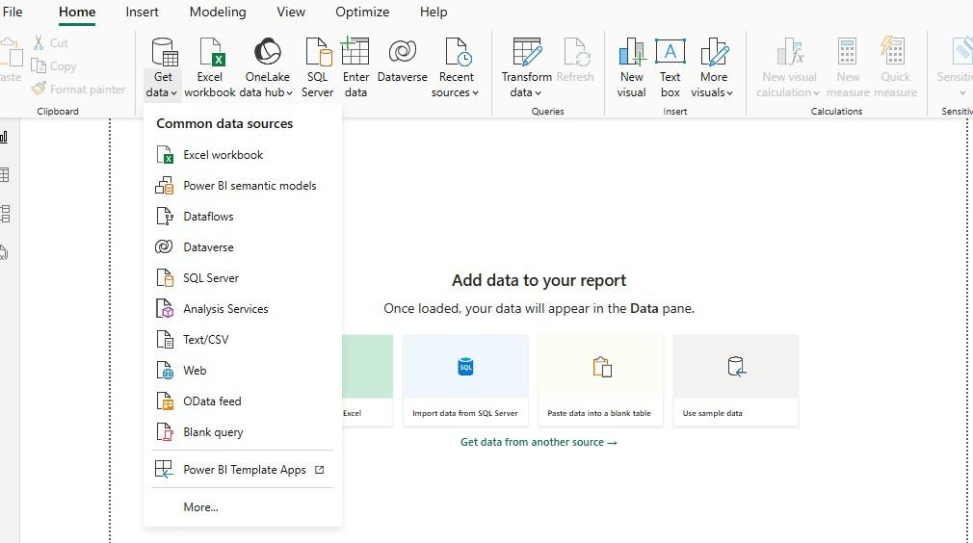

Step 3: Locate Your CSV File

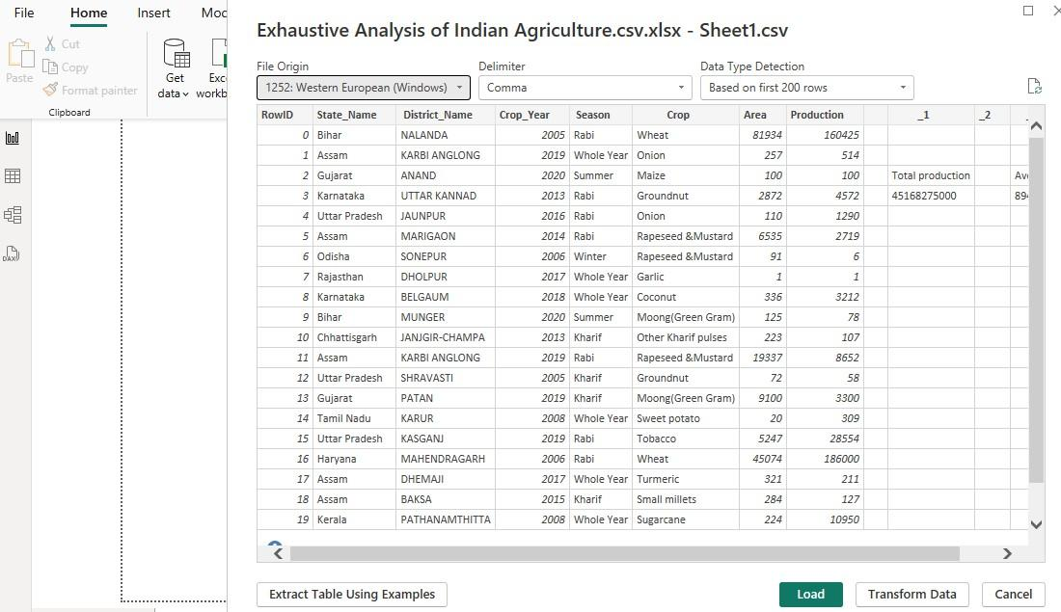

Step 4: Preview data

Step 5: Load data

# Data Preprocessing

Step 1: After importing your data, if you need to transform it, click Transform Data.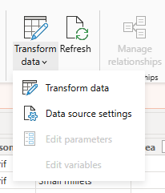

Step 2: Open Power Query Editor

Step 3: Remove Unnecessary Columns.

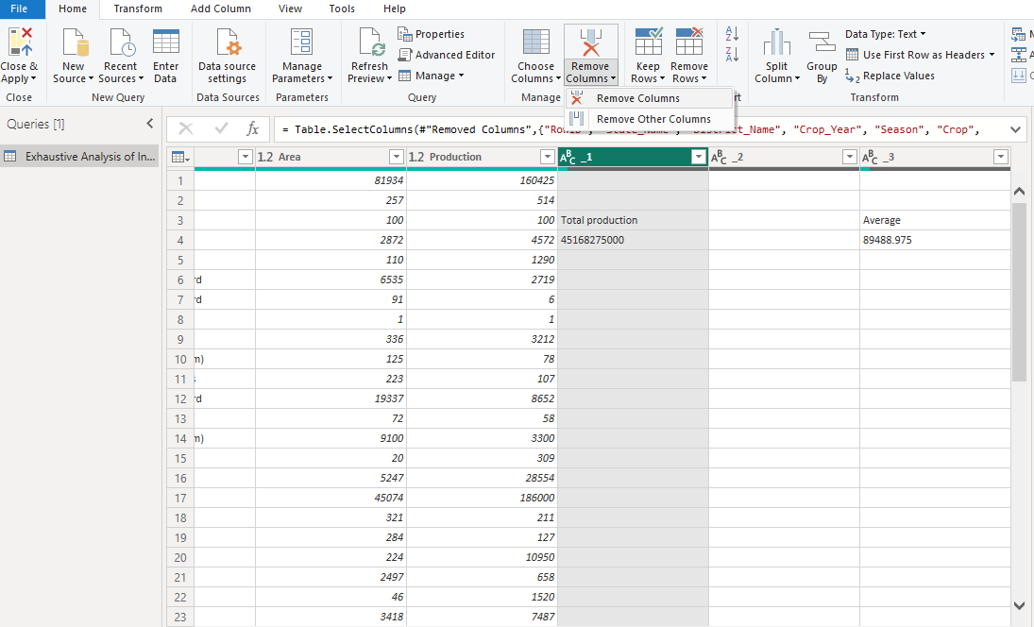

Step 4: Right-click the column header and select Remove or select the column and click Remove Columns in the ribbon.

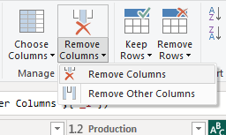

Step 5: Click Close & Apply to save and apply your changes to Power BI.

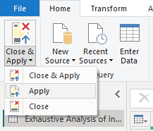

1. **Assessing the Quality of our column**

Step 1: Open Power Query Editor

Step 2: Click on any column header to select the column you want to analyze. Step 3: In the View tab of the ribbon (located at the top of the Power Query Editor), check the option called Column Quality.

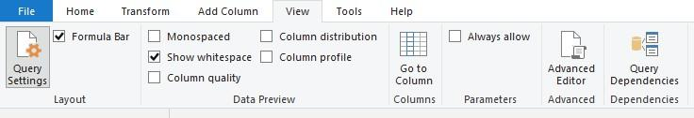

Step 4: Once enabled, you’ll see a small bar chart above each column header, representing the distribution of valid, empty, and error values

* Green bars represent the valid values in the column.
* Yellow bars represent empty (null) values.
* Red bars represent error values.

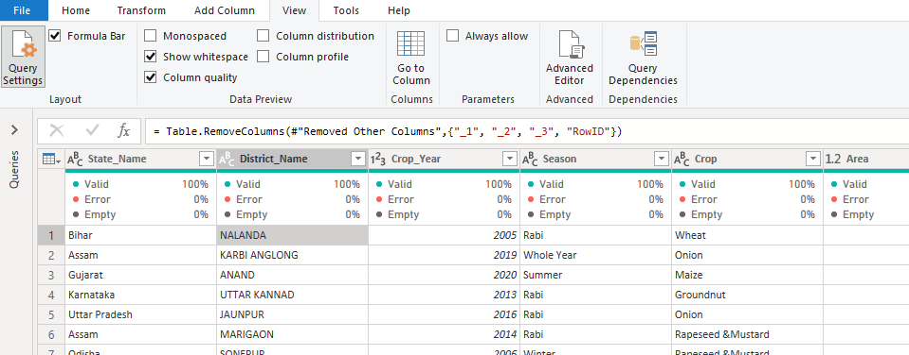

**NOTE:**

1. All the changes that we have made so far in the document will appear in the Applied steps bar.
2. As we apply transformations like removing columns, filtering rows, changing data types, Power BI automatically records each transformation in the Applied Steps pane on the right side of the screen.